T-Fusion™

Platform for Oral Delivery of Recombinant Proteins
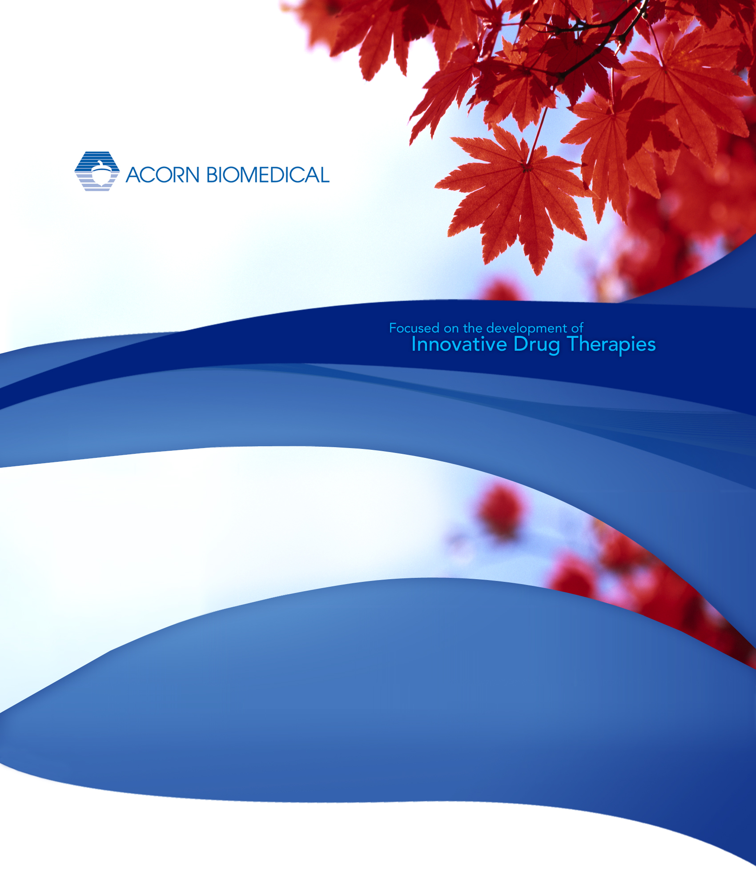

Overview

Recombinant protein and peptide pharmaceuticals are mainstream products in the pharmaceutical industry. Patients take these drugs by injection, as oral formulations of recombinant protein and peptide drugs are not commercially available. Despite a demonstrated need for protein and peptide drugs, doctors and patients can be reluctant to use such medications because of the requirement for frequent and repeated injections.

T-Fusion™ is a receptor mediated oral absorption technology utilizing a natural transcellular pathway that has been broadly shown to enable pulmonary and oral delivery of large protein-based therapeutic molecules in animals. Absorption of proteins via the transferrin receptor does not alter cellular processes and is not detrimental to the membrane integrity of the gastrointestinal tract. Transferrin is resistant to gastrointestinal digestion and its receptors are abundantly expressed in the human GI tract.

By enabling protein and peptide therapeutics to be administered orally, T-Fusion™ technology will simplify the administration of these drugs, generate wider patient use and acceptance, and provide substantial cost savings through eliminating the health care costs associated with the injection of protein and peptide therapeutics.

Oral delivery of therapeutic proteins

Early work on this technology entailed chemical conjugation of transferrin to therapeutic proteins of interest. Orally administered G-CSF-transferrin conjugates were shown to increase white blood cell counts in rodents. Similarly, oral insulin-transferrin conjugates were shown to lower blood sugar in diabetic rats. The major obstacle with the chemical conjugation methodology is that the chemically cross-linked products were poorly defined heterogeneous mixtures that tended to form polymeric products. The high cost of manufacturing purified transferrin chemical conjugates prohibited their development into commercially viable drugs.

T-Fusion™ is a platform technology that utilizes recombinant DNA technology to produce fusion proteins consisting of a therapeutic protein coupled to a transferrin carrier. These protein products are orally bioavailable and retain the biological activity of the payload therapeutic protein. T-Fusion™ proteins can be produced and purified at commercial scale utilizing existing protein manufacturing methodologies.

The lead product under development with the T-Fusion™ technology is a fusion protein of G-CSF (ACN-8337). ACN-8337 retains the biologic activity of G-CSF, is absorbed intact across Caco-2 cells in vitro by transferrin-receptor mediated transport, and produces a myelopoietic effect upon injection into rodents. Oral administration of ACN-8337 to mice showed effective GI absorption with an attendant increase in absolute neutrophil count (Figure 1). Oral bioequivalence of ACN-8337, as assessed by peak absolute neutrophil count (ANC) in comparison to injected Neupogen®, is on the order of 20% (Figure 2).

Figure 1. Myelopoietic effect of single oral doses of ACN-8337, Neupogen® and control in BDF1 mice.

Figure 2. Oral bioequivalence of ACN-8337 compared to injected Neupogen®.
The T-Fusion™ platform also encompasses a recombinant protein prodrug technology designed to release free therapeutic proteins into the systemic circulation following oral administration. Prodrugs that undergo chemical conversion in the body to become an active drug are widely used with small molecules to circumvent problems associated with oral bioavailability. This approach has been applied to recombinant therapeutic proteins through the creation of a temporary linkage between the transferrin carrier protein and the payload therapeutic protein. In animal studies, such a recombinant protein prodrug of G-CSF has been shown to release therapeutic levels of free G-CSF into the systemic circulation.

The worldwide market for therapeutic recombinant proteins was over $40 Billion in 2007. The T-Fusion™ platform is applicable to a wide range of recombinant therapeutic proteins, such as erythropoietin, growth factors, blood clotting factors, growth hormones, reproductive hormones and replacement enzymes. With pharmaceutical level oral bioavailability and existing manufacturing methods for production of recombinant proteins, orally administered therapeutic proteins based on the T-Fusion™ technology are anticipated to deliver gross margins in excess of 90%.

Detailed information on T-Fusion™ and the research and development conducted to-date will be made available upon request.

